MEDIA RELEASE
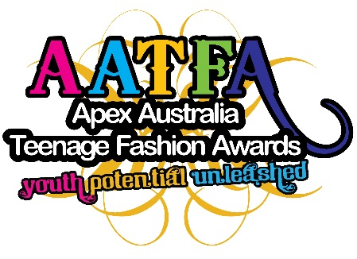

YOUNG DESIGNER CALLS FOR SUPPORT OF TEENAGE FASHION AWARDS
Fashion lover Holly Whitty has an age-old message for secondary students eyeing a job in Australia’s competitive fashion industry – find what you love doing and make it your career!
Now studying Design at RMIT, Ms Whitty will be showcasing her designs at the upcoming National Final of the Apex Australia Teenage Fashion Awards on October 25th at the Whitehouse Institute, after being a participant in this exciting national event.
Apex Australia, a service organisation for young people aged 18-45 runs the national event by supporting teenagers with a passion for fashion, giving talented students a chance to glimpse a future in fashion.
“The AATFA competition was an exciting event to look forward to during high school, and gave the assignments within our textiles class a brilliant purpose,” said Ms Whitty.
“It was also great exposure into the fashion industry.”
Since leaving school, Ms Whitty has worked in a number of fashion focused roles, and is leaning towards production for her future career.
Working specifically with MYER Exclusive Brands, her role involves analysing and adjusting fit and construction with numerous Buying Teams to ensure all garments delivered to store achieve consistency to the MYER Quality Assurance Standards.
“The technical side of design has always interested me - it is what sets apart a nice drawing from a functional and commercial garment.”
Ms Whitty is urging all high school students keen on design and art to consider entering the Apex Australia Teenage Fashion Awards (AATFA).
“Being involved in AATFA over 2 years was extremely exciting. The chance to showcase your work in a professional environment against the top students from around the country was incredible and something I will always remember,” she said.
AATFA National Coordinator Sarah Clark, said there were four categories in the competition: casual wear, formal wear, wearable art and society and environment.
“Each state will select two finalists from each category at the State Final before competing at the prestigious national final where the Australian Young Designer of the Year will be crowned,” said Ms Clark.
So if you have a passion for fashion, and would like to share in this fantastic opportunity, speak with your Textile or Art teacher about getting together an entry.
For more information and a look at previous year’s winners go to www.aatfa.org.au
Then hit the sewing machine!

For enquiries:

Jeff Hardie
Media Coordinator
Apex Australia Teenage Fashion Awards
0409 050 547
aatfa@live.com.au
www.aatfa.org.au

